LAB No – 03
Aim – Performing DQN (Deep Q learning)
Theory - Deep Q-Learning is a method that uses deep learning to help machines make decisions in complicated situations. It’s especially useful in environments where the number of possible situations called states is very large like in video games or robotics.
Before understanding Deep Q-Learning it’s important to understand the main concept of Q Learning It is a model-free method that learns an optimal policy by estimating the Q-value function which tells how good it is to take a certain action in a certain situation. The goal is to find a plan that gives the highest total reward over time.
Architecture of Deep Q-Networks
A DQN consists of the following components:
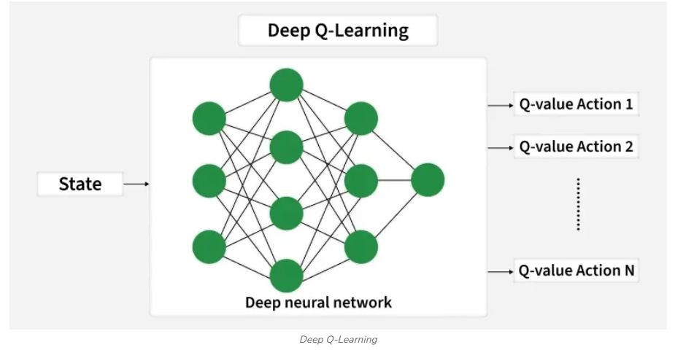
Applications
Deep Q-Learning is used in many areas such as:
- Atari Games: It can learn to play old video games very well even better than humans by looking at the screen pixels.
- Robotics: It helps robots to learn how to pick objects, move around and do tasks with their hands.
- Self-Driving Cars: It helps cars to make decisions like changing lanes and avoiding obstacles safely.
- Finance: It is used to find the best ways to trade stocks, manage money and reduce risks.
- Healthcare: It helps with planning treatments, discovering new medicines and personalizing care for patients.
Code

import gymnasium as gym
import gymnasium as gym
import ale_py
from stable_baselines3 import DQN
from stable_baselines3.common.atari_wrappers import AtariWrapper
from stable_baselines3.common.vec_env import DummyVecEnv

env = gym.make("PongNoFrameskip-v4", render_mode="human")
env = AtariWrapper(env)

env = DummyVecEnv([lambda: env])

model = DQN(
"CnnPolicy",
env,
learning_rate=1e-4,
buffer_size=50000,
learning_starts=1000,
batch_size=32,
gamma=0.99,
verbose=1,
tensorboard_log="./pong_dqn/"
)

model.learn(total_timesteps=100000)

model.save("pong_dqn")

obs = env.reset()
while True:
action, _ = model.predict(obs)
obs, reward, done, info = env.step(action)

Output
